**Знакомство с веб-технологиями. Обучение в записи**

**Урок 8. Семинар. Основы бэкенда: PHP и MySQL**



Оглавление

Задание № 1 2

Задание № 2 2

Задание № 3 4

Задание № 4 5

Задание № 5 6

Домашнее задание 7

# Задание № 1



**Ход выполнения задания 1.**

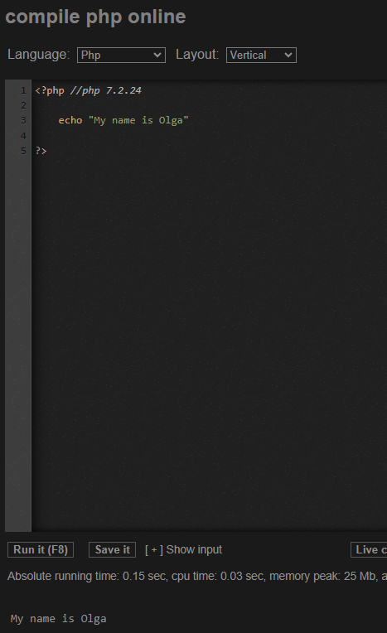 

ИЛИ

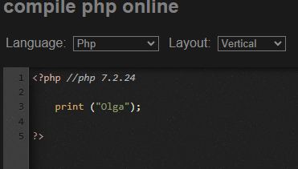 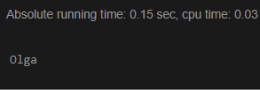

# Задание № 2

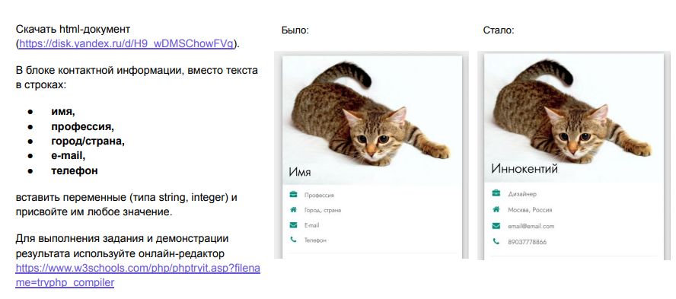

**Ход выполнения задания 2.**

<?php

$name = "Иннокентий";

$profession = "Дизайнер";

$country_city = "Россия, Москва";

$email = "email@email.com";

$phone = 8903777886;

?>

…

<div class="w3-white w3-text-grey w3-card-4">

<div class="w3-display-container">

<img src="https://imgfon.ru/Images/Details_img_880px/Animals/glaza-belyy_fon-kotik-morda-polosatyy.webp" style="width:100%" alt="Avatar">

<div class="w3-display-bottomleft w3-container w3-text-black">

<h2><?= $name ?></h2>

</div>

</div>

<div class="w3-container">

<p><i class="fa fa-briefcase fa-fw w3-margin-right w3-large w3-text-teal"></i><?php echo $profession; ?></p>

<p><i class="fa fa-home fa-fw w3-margin-right w3-large w3-text-teal"></i><?php echo $country_city ?></p>

<p><i class="fa fa-envelope fa-fw w3-margin-right w3-large w3-text-teal"></i><?php print($email) ?></p>

<p><i class="fa fa-phone fa-fw w3-margin-right w3-large w3-text-teal"></i><?php print($phone) ?></p>

<hr>

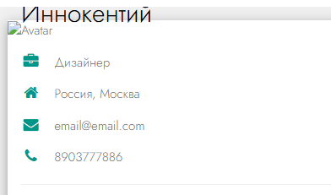

# Задание № 3

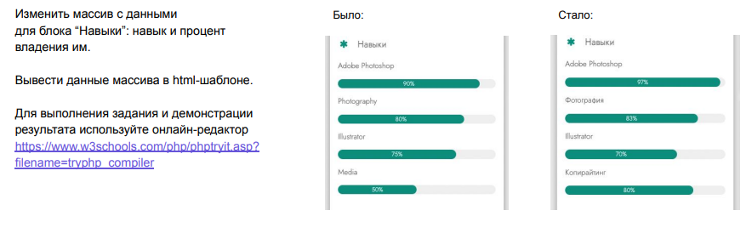

**Ход выполнения задания 3.**

<?php

$name = "Иннокентий";

$profession = "Дизайнер";

$country_city = "Россия, Москва";

$email = "email@email.com";

$phone = 8903777886;

$skills = ['skills_name' => [

'Adobe Photoshop',

'Фотография',

'Illustrator',

'Копирайтинг'],

'level' => [97, 83, 70, 80]

]

?>

…..

<p class="w3-large"><b><i class="fa fa-asterisk fa-fw w3-margin-right w3-text-teal"></i>Навыки</b></p>

<p>

<?php echo $skills['skills_name'][0]; ?>

</p>

<div class="w3-light-grey w3-round-xlarge w3-small">

<div class="w3-container w3-center w3-round-xlarge w3-teal" style="width:<?php echo $skills['level'][0]; ?>%">

<?php echo $skills['level'][0]; ?>

</div>

</div>

<p>

<?php echo $skills['skills_name'][1]; ?>

</p>

<div class="w3-light-grey w3-round-xlarge w3-small">

<div class="w3-container w3-center w3-round-xlarge w3-teal" style="width:<?php echo $skills['level'][1]; ?>%">

<div class="w3-center w3-text-white">

<?php echo $skills['level'][1]; ?>

</div>

</div>

</div>

<p>

<?php echo $skills['skills_name'][2]; ?>

</p>

<div class="w3-light-grey w3-round-xlarge w3-small">

<div class="w3-container w3-center w3-round-xlarge w3-teal" style="width:<?php echo $skills['level'][2]; ?>%">

<?php echo $skills['level'][2]; ?>

</div>

</div>

<p>

<?php echo $skills['skills_name'][3]; ?>

</p>

<div class="w3-light-grey w3-round-xlarge w3-small">

<div class="w3-container w3-center w3-round-xlarge w3-teal" style="width:<?php echo $skills['level'][3]; ?>%">

<?php echo $skills['level'][3]; ?>

</div>

</div>

<br>

….

</body>

</html>

# Задание № 4

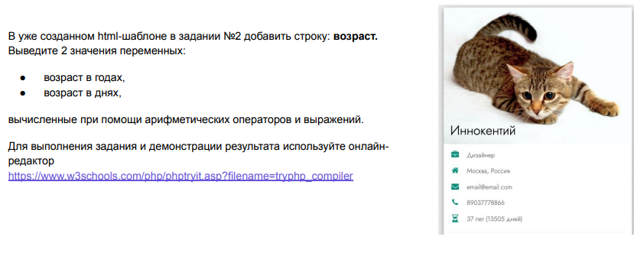

**Ход выполнения задания 4.**

<?php

$name = "Иннокентий";

$profession = "Дизайнер";

$country_city = "Россия, Москва";

$email = "email@email.com";

$phone = 8903777886;

$age = 2024-1984;

$days = (2024-1984)*365;

$skills = ['skills_name' => [

'Adobe Photoshop',

'Фотография',

'Illustrator',

'Копирайтинг'],

'level' => [97, 83, 70, 80]

]

?>

…….

<p>

<i class="fa-hourglass-half fa-fw w3-margin-right w3-large w3-text-teal"></i>

<?= $age ?> лет (<?= $days ?> дней)

</p>

<hr>

…..

</body>

</html>

# Задание № 5

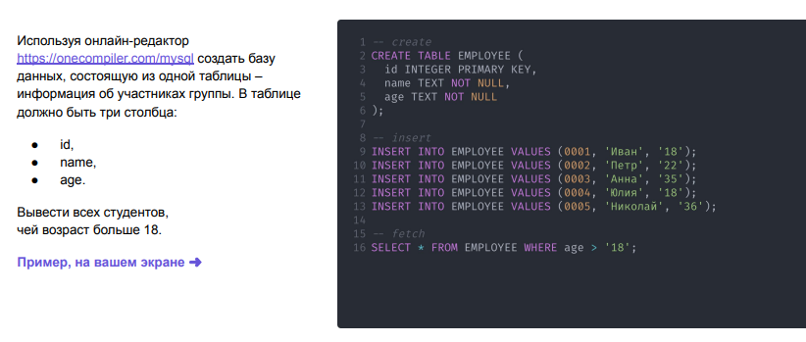

**Ход выполнения задания 5.**

-- create

CREATE TABLE GROUP_STUDENT (

id INTEGER PRIMARY KEY NOT NULL,

name TEXT NOT NULL,

age INTEGER NOT NULL

);

-- insert

INSERT INTO GROUP_STUDENT VALUES (1, 'Иван', 18);

INSERT INTO GROUP_STUDENT VALUES (2, 'Петр', 22);

INSERT INTO GROUP_STUDENT VALUES (3, 'Анна', 35);

INSERT INTO GROUP_STUDENT VALUES (4, 'Юлия', 18);

INSERT INTO GROUP_STUDENT VALUES (5, 'Николай', 36);

-- fetch

SELECT * FROM GROUP_STUDENT WHERE age > 18;

# Домашнее задание



**Ход выполнения домашнего задания 1:**

<?php

$name = "Иннокентий";

$profession = "Дизайнер";

$country_city = "Россия, Москва";

$email = "email@email.com";

$phone = 8903777886;

$age = 2024-1984;

$days = (2024-1984)*365;

$skills = ['skills_name' => [

'Adobe Photoshop',

'Фотография',

'Illustrator',

'Копирайтинг'],

'level' => [97, 83, 70, 80]

];

$experience = ['experience_name' => [

'Front End Developer',

'Web Developer / something.com',

'Graphic Designer / designsomething.com'],

'period' => ['Jan 2015 - ', 'Mar 2012 - Dec 2014', 'Jun 2010 - Mar 2012'],

'inform' => [

'Lorem ipsum dolor sit amet. Praesentium magnam consectetur vel in deserunt aspernatur est reprehenderit

sunt hic. Nulla tempora soluta ea et odio, unde doloremque repellendus iure, iste.',

'Consectetur adipisicing elit. Praesentium magnam consectetur vel in deserunt aspernatur est reprehenderit

sunt hic. Nulla tempora soluta ea et odio, unde doloremque repellendus iure, iste.',

'Lorem ipsum dolor sit amet, consectetur adipisicing elit.'

]

]

?>

**……**

<div class="w3-container w3-card w3-white w3-margin-bottom">

<h2 class="w3-text-grey w3-padding-16"><i

class="fa fa-suitcase fa-fw w3-margin-right w3-xxlarge w3-text-teal"></i>Опыт работы</h2>

<div class="w3-container">

<h5 class="w3-opacity"><b>

<?php echo $experience['experience_name'][0]; ?>

</b></h5>

<h6 class="w3-text-teal"><i class="fa fa-calendar fa-fw w3-margin-right"></i>

<?php echo $experience['period'][0]; ?><span class="w3-tag w3-teal w3-round">Current

</span>

</h6>

<p><?php echo $experience['inform'][0]; ?></p>

<hr>

</div>

<div class="w3-container">

<h5 class="w3-opacity"><b>

<?php echo $experience['experience_name'][1]; ?>

</b></h5>

<h6 class="w3-text-teal">

<i class="fa fa-calendar fa-fw w3-margin-right"></i>

<?php echo $experience['period'][1]; ?></h6>

<p><?php echo $experience['inform'][1]; ?></p>

<hr>

</div>

<div class="w3-container">

<h5 class="w3-opacity"><b>

<?php echo $experience['experience_name'][2]; ?>

</b></h5>

<h6 class="w3-text-teal"><i class="fa fa-calendar fa-fw w3-margin-right"></i>

<?php echo $experience['period'][2]; ?></h6>

<p><?php echo $experience['inform'][2]; ?></p><br>

</div>

</div>

**……**

**Ход выполнения домашнего задания 2:**

-- create

CREATE TABLE GROUP_STUDENT (

id INTEGER PRIMARY KEY NOT NULL,

name TEXT NOT NULL,

age INTEGER NOT NULL,

address TEXT NOT NULL

);

-- insert

INSERT INTO GROUP_STUDENT VALUES (1, 'Иван', 18, 'Москва');

INSERT INTO GROUP_STUDENT VALUES (2, 'Петр', 22, 'Санкт-Петербург');

INSERT INTO GROUP_STUDENT VALUES (3, 'Анна', 35, 'Харьков');

INSERT INTO GROUP_STUDENT VALUES (4, 'Юлия', 18, 'Краснодар');

INSERT INTO GROUP_STUDENT VALUES (5, 'Николай', 36, 'Простоквашино');

-- fetch

SELECT * FROM GROUP_STUDENT;

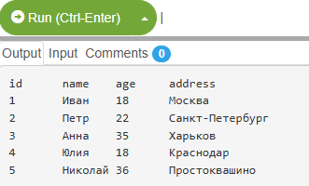

***Ссылка на репозиторий GitHub:***

[***https://github.com/olgashenkel/GeekBrains-specialization-ELECTIVES/tree/main/04.%20Introduction_to_web_technologies***](https://github.com/olgashenkel/GeekBrains-specialization-ELECTIVES/tree/main/04.%20Introduction_to_web_technologies)